
Names: Matthijs van Meeuwen, Dennis Leclou,
Fee van Zoghel and Bas Wensing

Teachers: Roy Willemen & Lonneke Driessen

Client: Esra-Sayiner Gürler (Transdev)

Subject: Project 5

Project Group: 5

User Manual
Project 5, Group 5
Contents
1. Introduction 2
2. Getting started 2
3. Right data format and data checks performed 3
4. Feasibility checks 5
5. Creating an improved bus planning 5
6. Analyzing KPI values and visualizations 7
7. Common mistakes 8

1. Introduction
This document has information that supplements the user manual video that was presented. This video supports users in their usage of the software tool. It is preferred to first watch the video. If you still have questions about using this tool, read this document. Focus on the part of the tool that is difficult to understand or use. In section 2-6, the most important steps to compare the original bus planning and improved bus planning are described. In section 7, common mistakes when using the tool are described.

2. Getting started
Opening the tool and first impressions of the tool
Put https://project5-improvedtool.streamlit.app/ in the search bar of a browser (like Chrome/Microsoft Edge/Google) and click on Enter. Be patient, opening the tool might take a minute or two. Check if the Transdev Planning Checker is opened in this browser (as in Figure 1). If it is not opened, recheck the URL you put in the search bar or try another browser. If the URL was correct and the browser worked, this action has opened the prototype software tool (Transdev Planning Checker).
Figure 1:
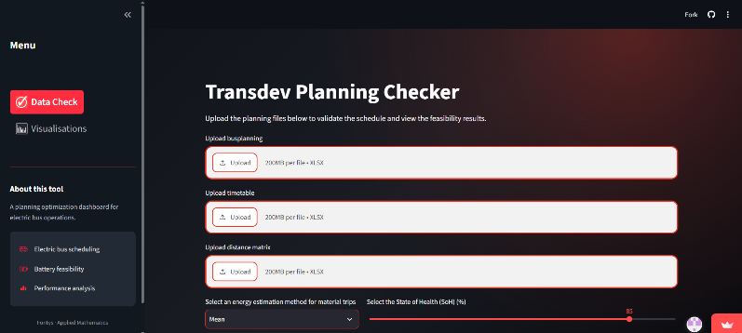
Main page of the Transdev Planning Checker

This software tool has two tabs: ‘Data check’ and ‘Visualizations’ which can be selected on the left side of the screen. If no data is imported, the visualizations tab will show the following: “Upload the bus planning, timetable and distance matrix on the data check page first”. Under the two tabs, there is a little description which explains the most important components of this tool (‘about this tool’).

Loading in data files
After opening the software tool, the first crucial step is loading in the data files for the bus planning, timetable, and distance matrix.
Click on ‘Data check’ on the menu to start uploading data files (see Figure 1).
Click on the upload button below ‘upload bus planning’ to load in the bus planning. Select the right bus planning file (Excel) in the file explorer. After selecting the right file, click on ‘Open’ or click on Enter.
Repeat above step for the timetable and distance matrix files.

3. Right data format and data checks performed
Data checks are executed when loading in data. Part of this process is checking the format of the Excel files including column names and data types. Both must be as required.
The bus planning Excel file must include the following columns (see Figure 2):
Figure 2:
Column names and data types for the bus planning Excel file.
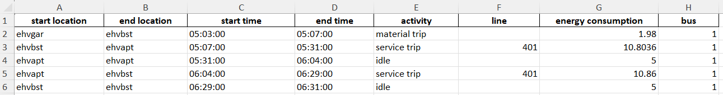

The data types must be:
- start location: text (string)
- end location: text (string)
- start time: date/datetime (HH:MM:SS)
- end time: date/datetime (HH:MM:SS)
- activity: text (string)
- line: integer
- energy consumption: float
- bus: integer
The timetable (in Excel) must include the following columns (see Figure 3):
Figure 3:
Column names and data types for the timetable Excel file.
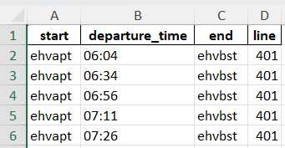
The data types must be:
- start: text (string)
- departure_time: date/datetime (HH:MM:SS)
- end: text (string)
- line: integer

The distance matrix (in Excel) must include the following columns (see Figure 4):
Figure 4:
Column names and data types for the distance matrix Excel file.
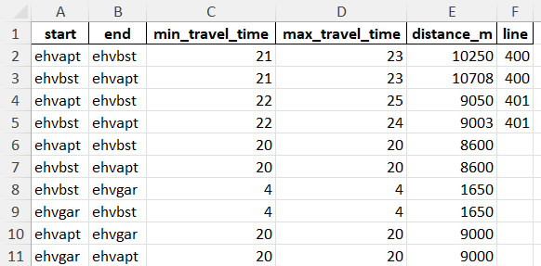
The data types must be:
- start: text (string)
- end: text (string)
- min_travel_time: integer
- max_travel_time: integer
- distance_m: integer
- line: integer
If any of the mentioned Excel files have a different layout, then data errors will occur on the screen (‘Data check’ tab). The error and row number in which the error has occurred will be shown. The Excel files then must be adjusted by a data cleaning process. This is not part of the software tool. If the Excel files are not in the right format, feasibility checks, KPI values and visualizations cannot be viewed. It is important to note that the timetable and distance matrix Excel files are from Transdev and should not cause any errors.

4. Feasibility checks
Figure 5:
If all feasibility checks are passed, the bus planning is feasible.
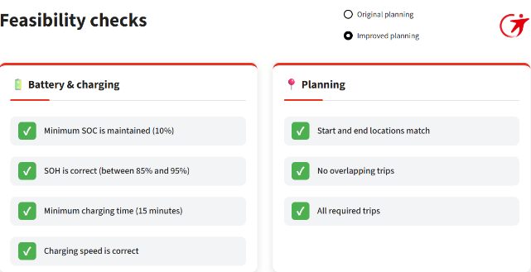
After loading in the data files, feasibility checks can be watched on the same tab (the Data check tab).
On the Data check page, scroll down to watch the Feasibility checks. A check mark (✅) means that a feasibility check has passed. A cross (❌) means that a feasibility check has failed. All feasibility checks must be passed to have a feasible bus planning schedule (see Figure 5).
Click on the button at the bottom of ‘Feasibility checks’ to get more information about the specific feasibility checks. If a feasibility error has occurred, then the error and row number will be shown after clicking on ‘Click here for details’ (see Figure 6). This can help to understand the errors that occurred.
Figure 6:
If not all feasibility checks are passed, errors will also be shown.
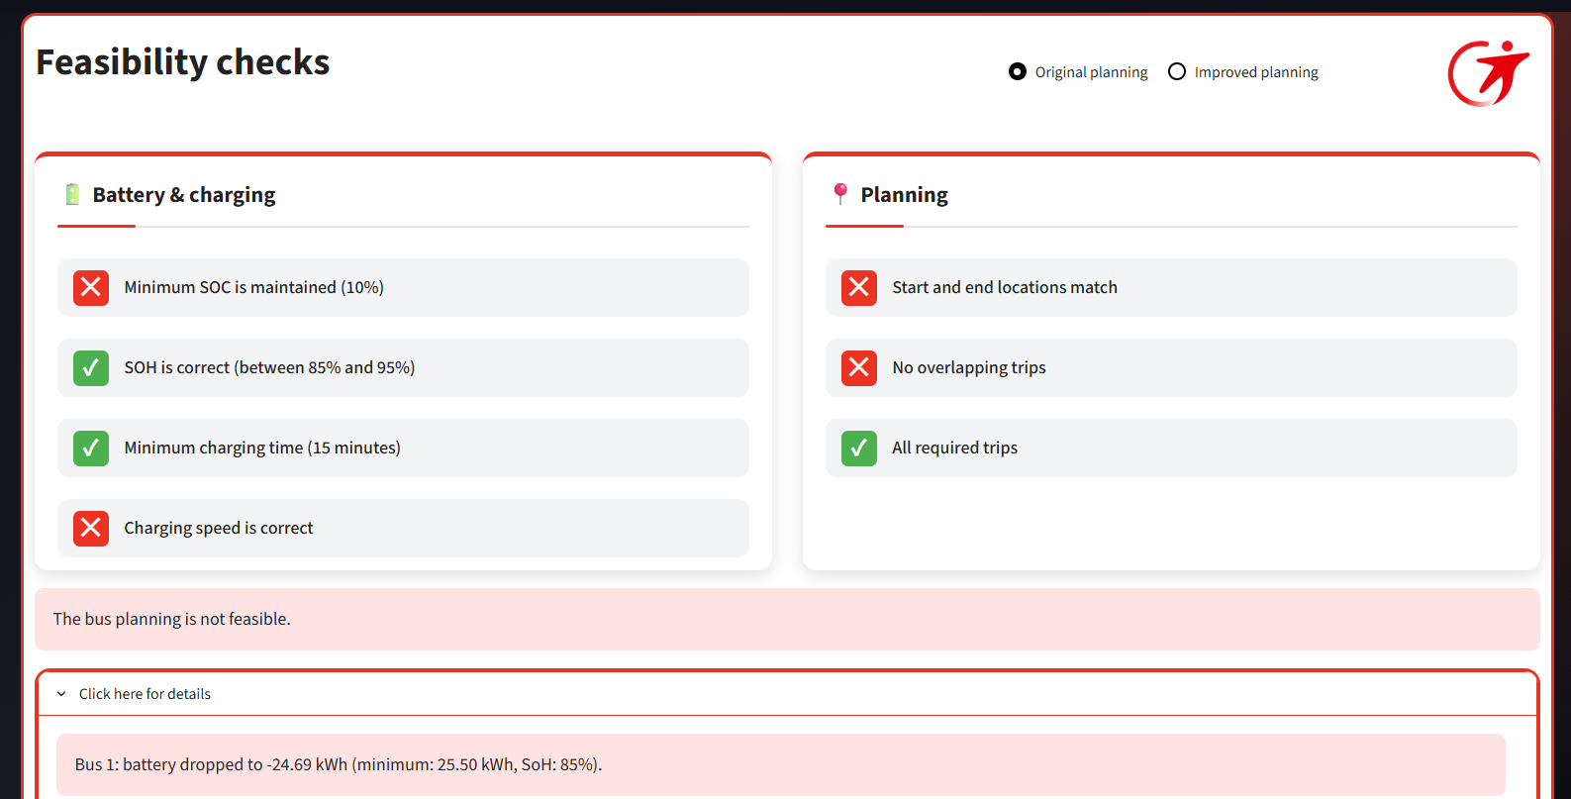

5. Creating an improved bus planning
The tool has an option to generate an improved bus planning based on a bus planning that was uploaded. Select the energy estimation method for material trips (mean, minimum, or maximum) and SOH value of the buses (as percentage) as settings for this improved bus plan (see Figure 7). The minimum method uses the minimum time for all trip lengths and the maximum method uses the maximum time for all trip lengths. The mean method calculates the duration for material trips as the average of the minimum time and maximum time. As an SOH value can be between 85% and 100% (by 1% increments).
Default settings are: mean as estimation method for material trips and 85% for the SOH value of the buses.
Figure 7:
Options for generating the improved bus planning.

Click on the Optimize button to generate an improved bus plan (see Figure 8). This takes around 15-30 seconds, and the process is visible (as percentage). Now, a ”Download improved bus planning’’ option will be visible (see Figure 8). Click on this button to download the improved bus planning as an Excel file. Click on “Downloads” in your file explorer to open find this Excel file on your PC.
Figure 8:
Generating an improved bus planning and downloading is included in the software tool.
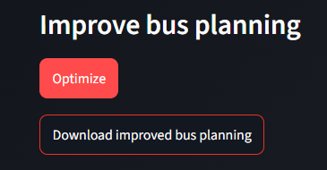

6. Analyzing KPI values and visualizations
KPI values and visualizations
Figure 9:
The KPI values of two bus plans can be compared.
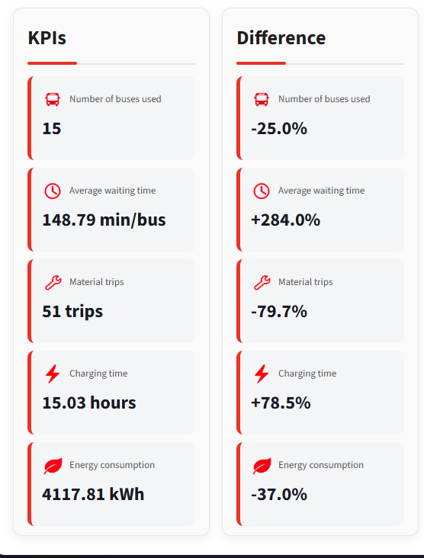
Click on Visualizations tab to view KPI values and visualizations. On this tab the original bus planning and new bus planning can be compared (see Figure 9).
On the left side of the screen, watch the KPI values. The KPI values that are shown, are: number of buses used, average waiting time, material trips, material trip distance, charging time, energy consumption, and total driven distance. Click on “Show more KPIs” to see additional KPI values.
On the right side of the screen, watch the bus planning as a Gantt chart visualization. Scroll down and delete or add buses if wanted. An option is to include all buses is also available in this tool. Select ‘’Original Planning’’ if you want to see the Gantt chart for the original bus planning. Select “Improved planning” if you want to see the Gantt chart for the Improved planning.

Comparison of original bus plan and new bus plan
Click on the visualizations tab to compare the original bus plan and the new bus plan. The Gantt chart shows the schedule per bus. The Gantt chart for only one solution method can be seen at a time (see Figure 10). Both bus plannings can be selected, as described in last section.
Figure 10:
Default is a Gantt chart for the improved planning.
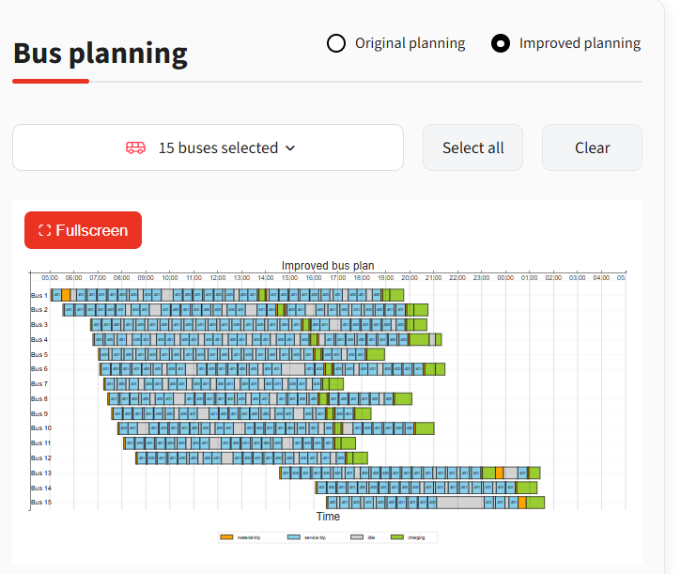
Look at the KPI values and difference on the left side of the screen to compare the KPI values of both bus plans. The KPI values shown are the KPI values from the bus plan that is selected on the top right-hand corner of the bus planning. The difference shows the difference in percentages from the improved bus plan compared to the original bus plan. These percentages are calculated by the following formula:
$Difference \left(\%\right)=\frac{KPI_{Original bus planning}-KPI_{Improved bus planning}}{KPI_{Original bus planning}}*100\%$

Meaning of the output
Output can be expected after correctly loading the right data files in. This output includes feasibility checks, KPI values and visualizations (Gantt charts).
Click on the Data check tab and scroll down to view the feasibility checks. Look if all feasibility checks are passed, the program marks if all feasibility were passed: ''The bus planning is feasible”. If any feasibility check fails, the program indices “the bus planning is not feasible''.
Click on the visualizations tab to open the KPI values and visualization. The visualization is a Gantt chart which includes the service trips (blue label), idle trips (grey label), materials trips (orange label), and charging (green label). So, each color is a distinct activity (see Figure 11).
Figure 11:
Each color is a distinct activity.

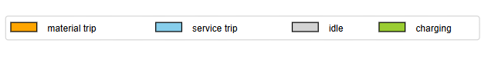

7. Common mistakes
The first common mistake when using the prototype software tool, is to upload the wrong file on the wrong upload button or to upload data that has not the right format (see Figure 12). The detailed option under the imports gives errors for missing columns for the bus planning and timetable (see Figure 12). In this case, the distance matrix is the only file that was imported correctly and has no data errors. In this case, there is stated “the uploaded data contains errors” (see Figure 12).
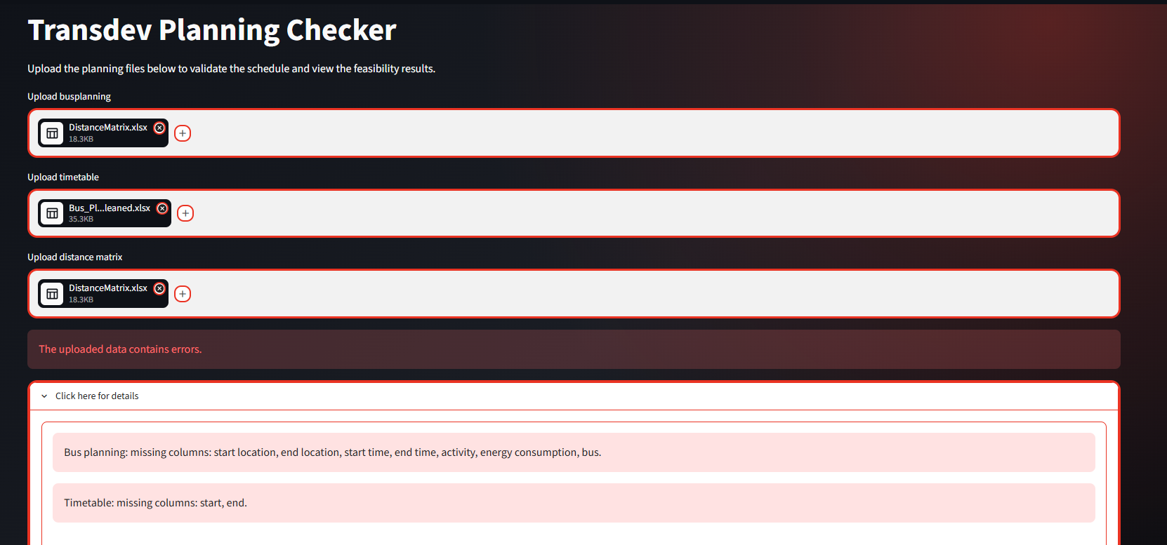
Figure 12:
Uploading the wrong files in the wrong place leads to errors.

The second common mistake is using the wrong settings for the improved bus planning. This results in an improved bus planning that does not fit the users’ requirements (see Figure 13).
Figure 13:
Wrong settings for improved bus planning if you want to create an improved bus planning based on maximum and SOH-value of 90%.
The third common mistake is to skip the feasibility checks, which results in KPI values and Gantt chart visualizations of a non-feasibility bus planning (see Figure 14). It is important to note that the improved bus planning is always feasible, meaning all feasibility checks are passed. This is also visible in the Gantt chart.
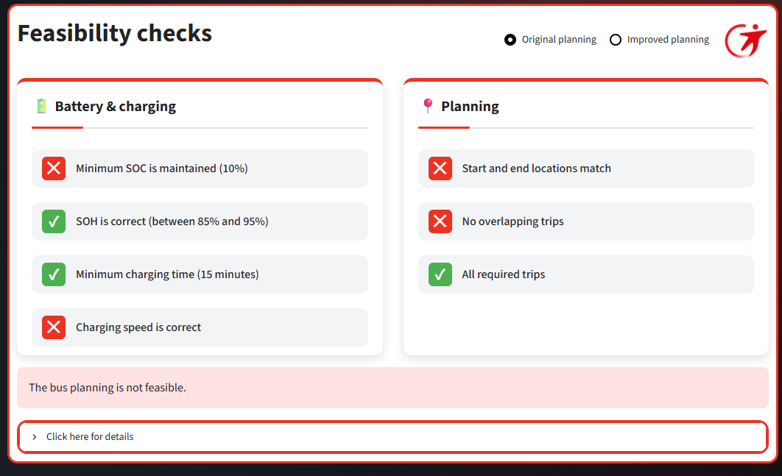
Figure 14:
A non-feasible bus planning.
The fourth common mistake is not finding the Visualizations tab. It can be found at the side bar under the Data Check tab (see Figure 15).
Figure 15:
The Data Check tab and Visualizations tab can be found on the Menu.
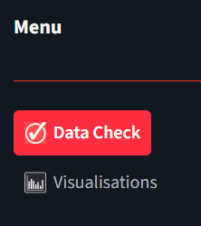

The fifth common mistake is forgetting to minimize the side bar. This makes the user less user-friendly. For example, the Visualizations can be seen less well (see Figure 16).

Figure 16:
Gantt chart for the improved bus plan while side bar is not minimized.
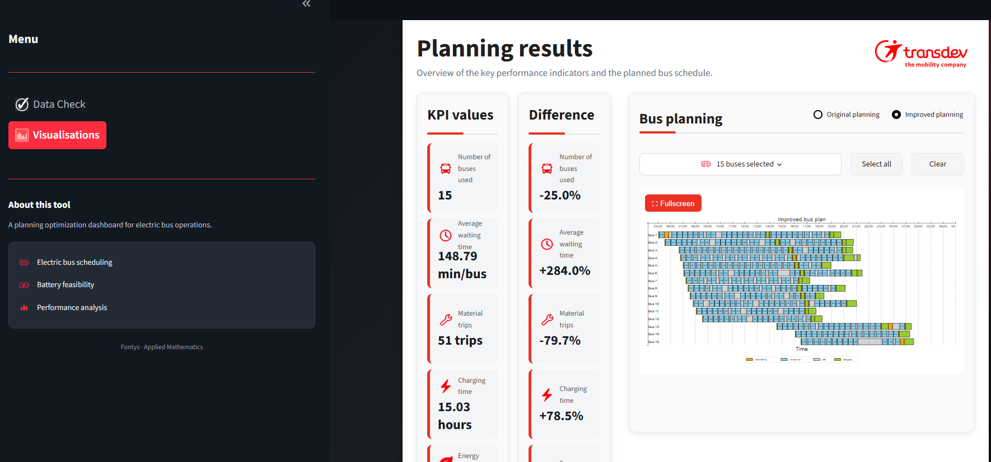

The sixth common mistake that can be made, is not saving the improved bus planning and losing the file. Remember, it was saved at ‘Downloads’ at the file explorer. After downloading, it is best to save the file in a folder you can find.
The seventh common is not selecting the right bus planning when doing feasibility checks or taking a look at the KPI values and Gantt chart.

